**REPUBLIQUE DU CAMEROUN**

Paix – Travail - Patrie

**REPUBLIC OF CAMEROON**

Peace - Work - Fatherland

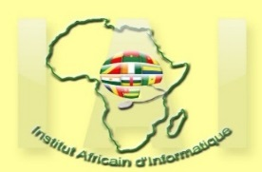



**AFRICAN INSTITUTE OF COMPUTER SCIENCES - CAMEROON OFFICE**

**PAUL BIYA TECHNOLOGICAL CENTER OF EXCELLENCE**

**P.O. Box : 13719 Yaoundé**

**Entreprise informatique**

Tel: (237) 691343955/657154855

Email: interface.cmr@gmail.com

Site Web: [www.lightinterface.cm](Web:%20www.camtel.cm)

P.O. Box: 13719 Yaoundé

Tel: +237.242.729.957 Fax: 22729958

E-mail : contact@iaicameroun.com

Web site: www.iaicameroun.com

**INTERNSHIP REPORT**

**THEME: MANAGEMENT OF AN ONLINE MEDICAL CONSULTATION PLATFORM**

Internship carried out from the 3rd of July till the 30th of September 2023. In view of obtaining an Engineering Diploma in Computer Sciences Option: Software Engineering

Written by:

**NDONGO JUNIOR DERLICH**

Level II Software Engineering student

Supervision:

Academic Supervisor:

**Mr. Ndengue**

Computer Engineering Lecturer at

AICS-Cameroon

Professional Supervisor

**Ms Jael Kalvin**

Software Engineer

**Academic Year 2022 - 2023**

0